Eazybe Onboarding: Your First Steps to AI-Powered WhatsApp
This guide will walk you through the entire Eazybe setup process, from creating your account and verifying your email to establishing your organization.
Start url: https://app.eazybe.com/signin
Access the Sign-in Page ( app.eazybe.com )
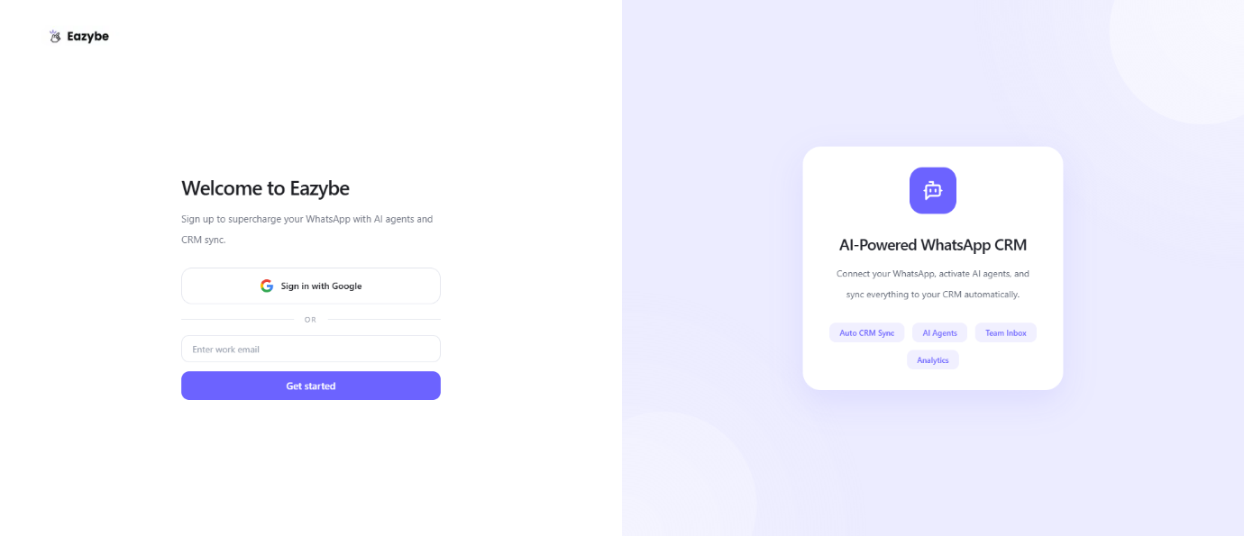

Enter your email or sign-in with google, Then click on get started
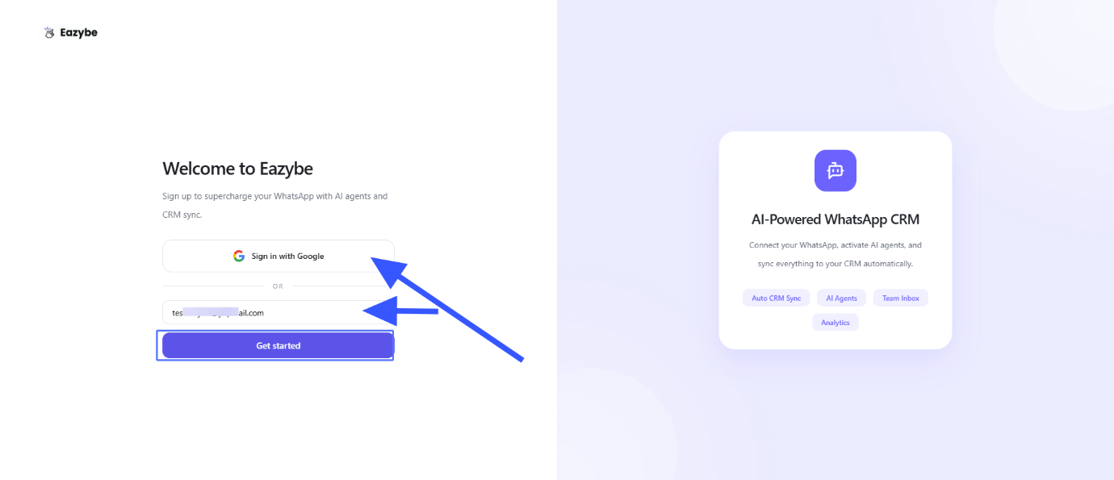

Enter the verification code, you received on your Email, Then click on Verify
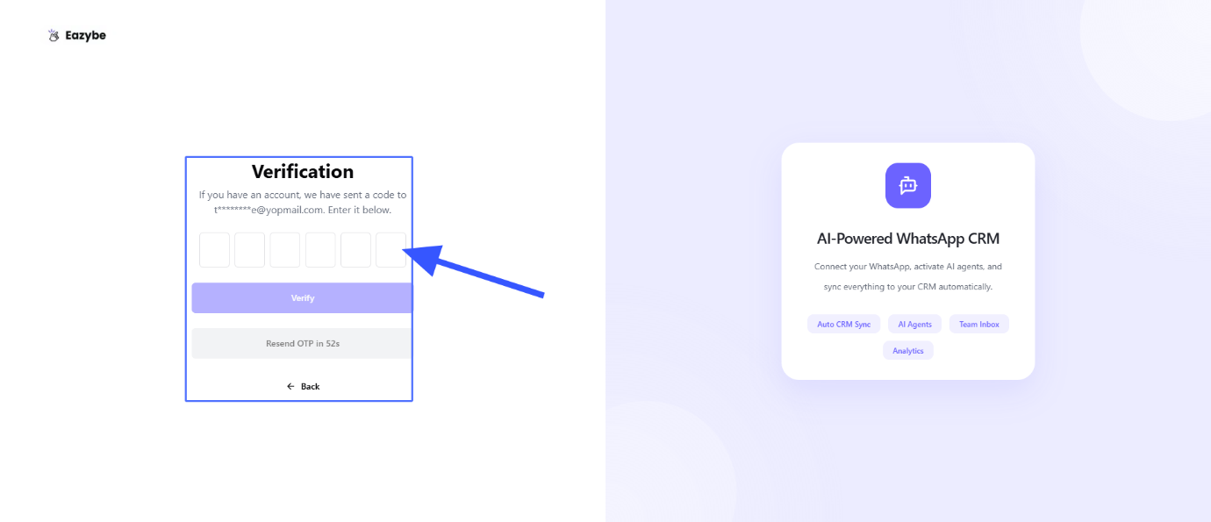

Set Up Your Workspace, You can join your existing Organization using the "organisation code" and can create a new Organisation , Then click on Continue
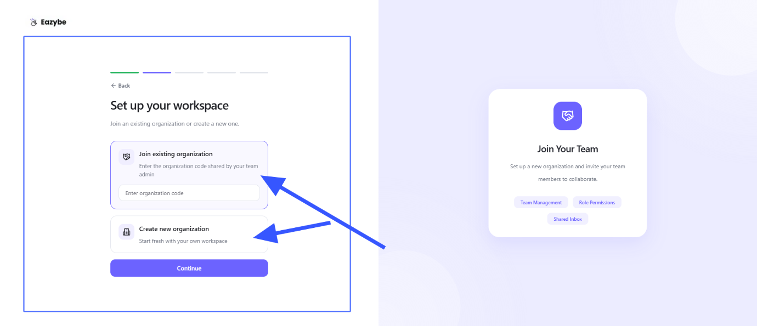

To create a new Organisation ,Enter Your Organization Name, Org logo ( optional ) and then click on Create Organisation
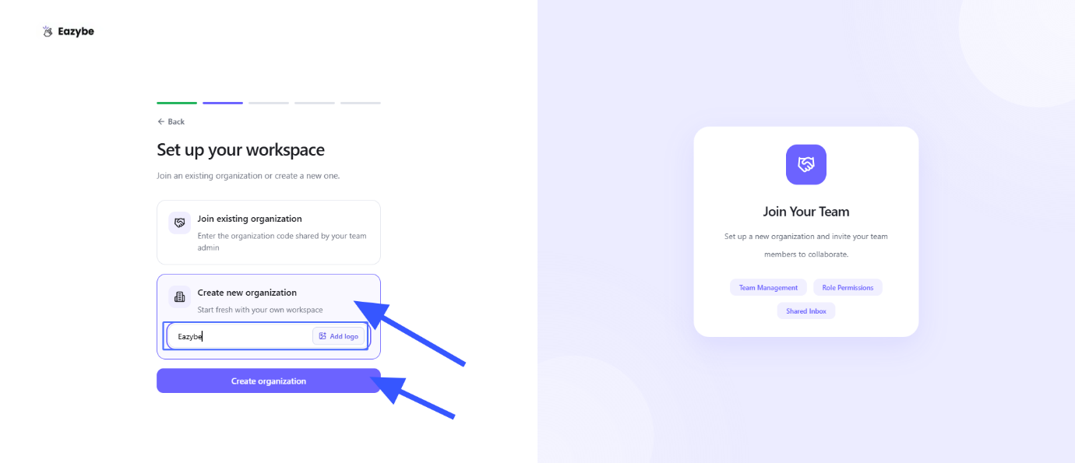

Set-up Flow: Chrome Extension Installation ( Optional ) , you can install it or can click on skip for now
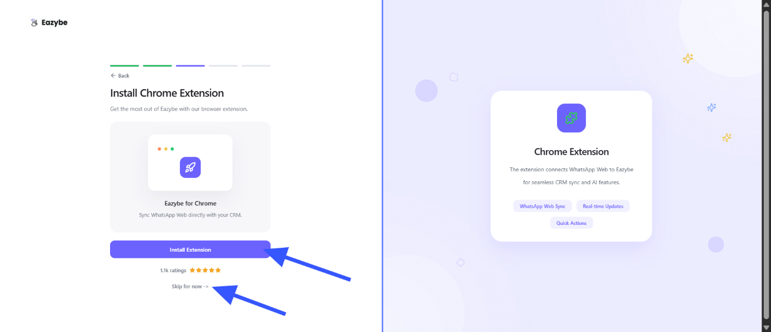

Set-up Flow: WhatsApp API Connection ( Optional ) , you can connect now or can click on skip for now
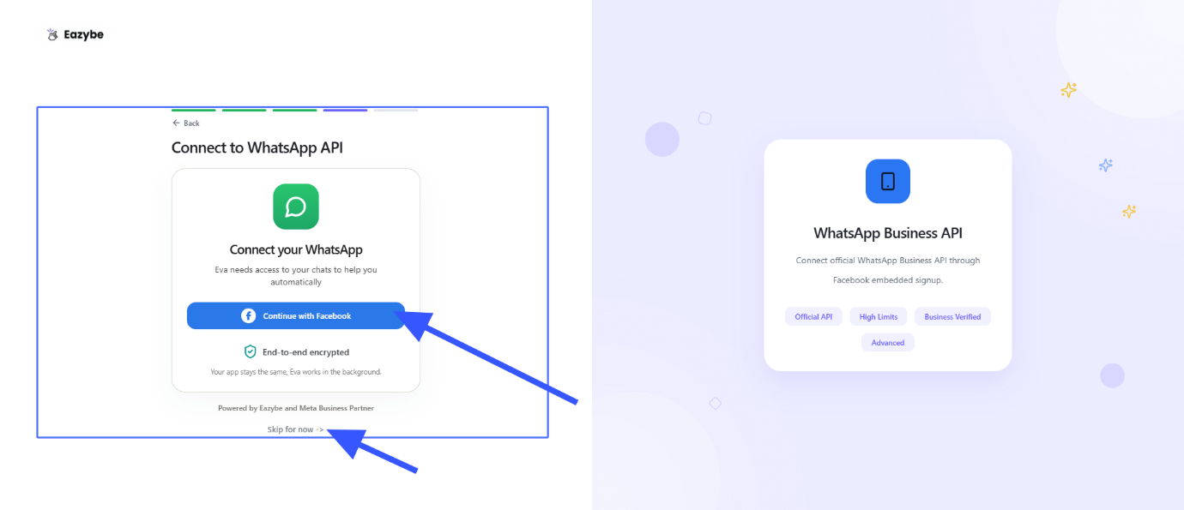

Set-up Flow: CRM Connection ( Optional ) , you can connect now or can click on skip for now
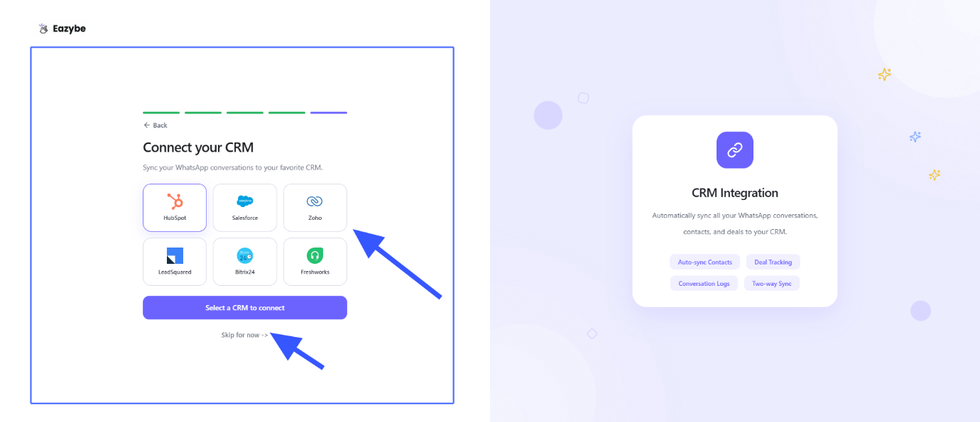

After the Successful setup you get a Free 4-Day trial with full access.
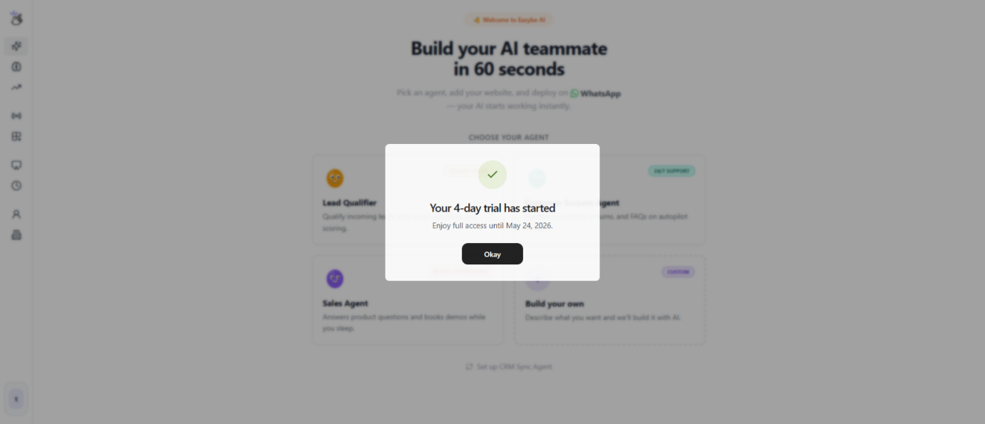

You have all the functionalities available on the Sidebar Navigation
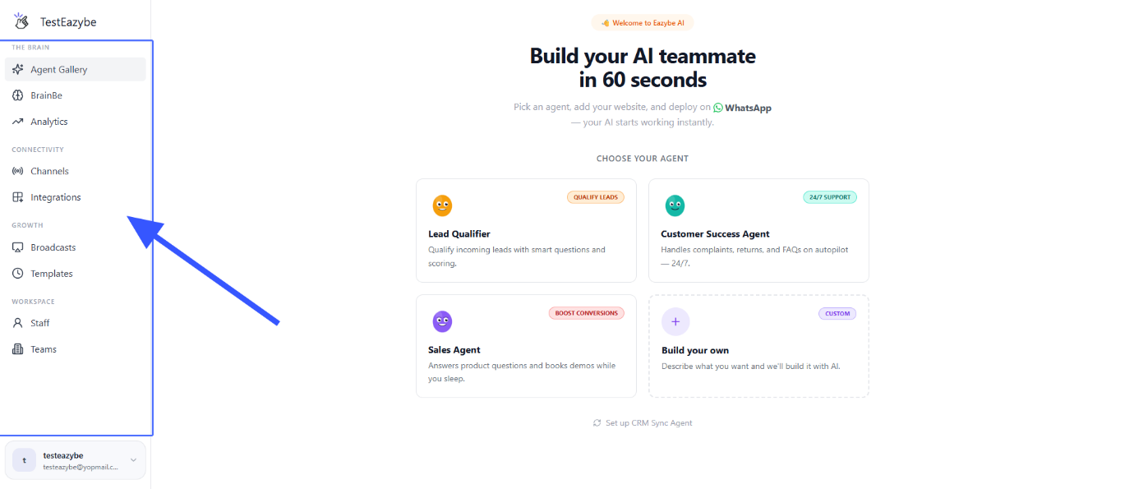

User Account management
